Mrs. Keri, Mrs. Brenda, Mrs. Brooke, and
Mrs. Kadee’s Weekly Buzz
January 17-21, 2022
Jan. 24 – CoGAT Testing
Jan. 27 – 100th Day of School!
Jan. 28 – SHARE FRIDAY!
Jan. 29 – Elijah’s Birthday
Feb. 14 – Valentine’s Day

Our Week in Review

This week we have enjoyed learning about shadows. I love watching kids “get it”, learning something new…and learning you must have light to have a shadow was one of those times!
Next week we will have our COGAT testing. This test is nothing to prepare for, but it would be helpful for your kiddo to GO TO BED EARLY and get some gooooood sleep so their brains can stay focused.

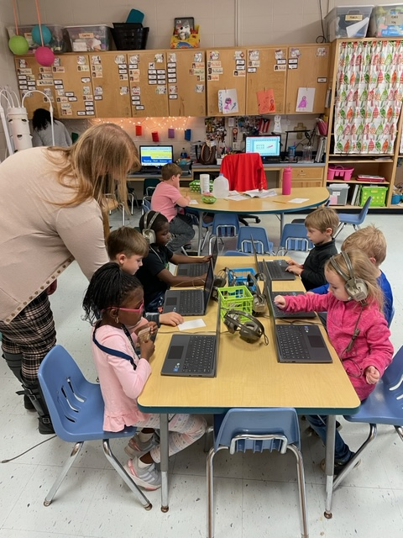

What we’ve been reading…

Amazing Arctic Animals
Vocab.: adaptations, tundra, blubber

Bunny Cakes
Vocab.: grocer, flour, iced, thrilled

This Week’s Sight Words!

has here her

Next Week’s Sight Words!

word your

